**Chapter 4 – Rational Functions Graphing Project**

Summary: For 20% of your Chapter 4 test score, you will work with a partner to create, analyze, and graph a rational function. The final product will be a **colorful** poster. **Due Monday, February 13.**

Make a Desmos Account:

Go to <https://www.desmos.com/calculator>. At least one partner must create an account. Use your ISQ student email address. Create and save a file called “Ch 4 Project – Member Names”. To do this, click on “Untitled Graph,” and then enter the name.

Designing Your Function:

Decide what you would like your graph to look like. It must have:

* 3 discontinuities: one hole, one VA, and one more of your choice (hole or VA). None of these may be at $x=0$. (Otherwise, you would not have a $y$-intercept.)
* Slant asymptote (So what does this mean about the degrees of the numerator and denominator?)
* A $y$-intercept and at least one $x$-intercept.

On Desmos, start by typing $f\left(x\right)=$ then hit the “ / ” button. This will create a fraction bar for you.

When designing your function, you should keep the numerator and denominator in **FACTORED** form.

Optional “Valley or Volcano” (+1 bonus) – On Desmos, examine $y=\frac{10x-3}{\left(x-2\right)\left(x-5\right){\left(x-10\right)}^{2}}$.   
Which discontinuity looks different from all the other ones we did in class?

Why do you think this happened? For one bonus point, when you make your third discontinuity, design it to be a “valley” or a “volcano.”

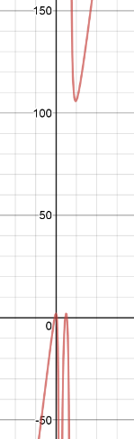

To keep your graph from getting ugly, the lead coefficient on your numerator (in standard form) should be less than or equal to the lead coefficient on your denominator (in standard form).

For example, a graph such as $y=\frac{\left(5x+1\right)\left( \right)\left( \right)\left( \right)}{\left(x+13\right)\left( \right)\left( \right)}=\frac{5x^{4}+…}{1x^{3}+…}$ would be a problem, since the slant asymptote would be very steep (slope $=5$), making the other aspects hard to see clearly ☹.

Find and Check Standard Form:

When you first design your function, it will be in factored form: $f\left(x\right)=\frac{\left( \right)\left( \right)\left( \right)\left( \right)}{\left( \right)\left( \right)\left( \right)}$. For your next step, simplify the top and bottom. (It might look something like $g\left(x\right)=\frac{2x^{4}+…}{7x^{3}+…}$ or with even higher degrees, if you do the extra credit.

To check your work, type both equations into Desmos. They should each create the same graph.

This is the form that you will start with at the top of your poster. See layout on next page. Then find the slant asymptote $h\left(x\right)=$… and type it into Desmos also. This will help you visually verify that you got it right. Remember to hit “Save.”

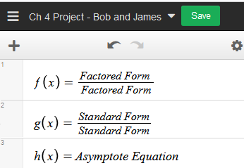

Getting Approval:

1. Your Desmos page should have 3 main equations
   1. $f(x)$: The function with top and bottom factored
   2. $g\left(x\right)$: The function with top and bottom in standard form
   3. $h\left(x\right)$: The equation of the asymptote

One nice thing about using “ $f\left(x\right)=$” instead of “ $y=$” is that you can go to a different line and plug in values, like “ $f\left(3\right)$,” which Desmos will then evaluate for you.

1. Get it approved by Mr. Malan. He will double check your calculations and whether you followed the instructions.
2. 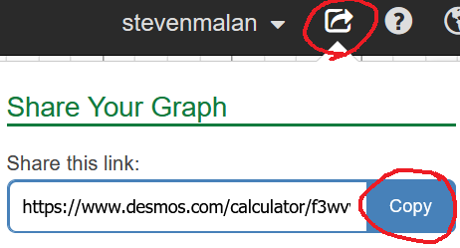After Mr. Malan approves it, upload a link to Canvas. That way, you and Mr. Malan will always have a record of your original plan. Note: On the Canvas assignment, it might ***look*** like you are done with the project after you paste in the link and submit. You must still create a poster, but Canvas does not know that.

Analysis:

Follow the steps shown in class notes. A random stranger walking through the hallway should be able to read your poster and follow your steps. For example, even if they don’t understand polynomial division, they should see it and be able to understand that it was related to your slant asymptote. Here is what you should include:

1. Holes
2. Vertical Asymptotes
3. $x$-intercepts
4. $y$-intercept
5. Slant Asymptote
6. Discontinuities*
7. Domain in interval notation.

*Discontinuities: If your graph has a hole at ( $e, 700)$ and a vert. asymptote at $x=$ 100, then you should say, “Discontinuities at $x=e$ and 100” (Notice: just the $x$ values.)

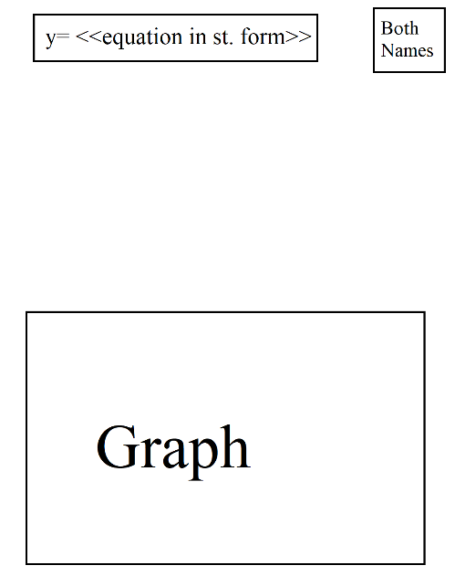Draft:

Create a draft poster on A4 paper (pencil okay). Scratch paper can be   
found in the classroom. Follow the general format shown here.  
The big empty space is where you will show your calculations.

Once your draft is complete, show it to Mr. Malan and he will give you a poster paper.

Use pencil to draft the final version. Finish with markers and erase any pencil. It should look good from 2m away.

Visual Aspect:

Your poster should be instructive and interesting!

Use color to help readers understand. For example, you could do something like this when finding the hole:

**Hole:** 🡪 Then $f\left(2\right)=\frac{2-3}{2-7}=-\frac{1}{5}$

Hole at $\left(2,-\frac{1}{5}\right)$

(And then your graph would show the hole in the same color.)

Avoid Wordiness: Notice in the hole example above, it was ***not*** necessary to write:  
“Since the algebraic factor $x-2$ was in both the numerator and denominator, there is a hole discontinuity at $x=2$. To find the $y$-value, we plug $x=2$ into the reduced function.”   
This would make your poster boring and hard to read. You should ***not*** have any complete sentences.

Focus on what is important: If there are long calculations (such as long division when finding the slant asymptote), make those parts smaller with the result “**Slant Asymptote: $y=\frac{1}{2}x+\frac{1}{7}$** ” larger.

Give a clear, organized presentation of all the graph’s features. Do not abbreviate this part.

Hole:   
Slant Asymptote:  
Vertical Asymptote: $x$ 
-Intercept: $y$  
-Intercept:  
Discontinuities:  
Domain:

H:   
SA:  
VA: $x$ 
-int: $y$  
-int:  
Dis:  
Dom:

Rubric:

|  |  |  |
| --- | --- | --- |
| **Topic** | **Earned** | **Total Possible** |
| Hole(s)   * Show process and show new reduced function * State hole(s) in ordered pair form |  | 2 |
| Vertical Asymptote(s)   * Show work and equation |  | 2 |
| $x$-intercept(s)   * Show work and ordered pair(s) |  | 2 |
| $y$-intercept   * Show work and ordered pair |  | 1 |
| Slant Asymptote   * Show process * Show asymptote equation |  | 4 |
| Discontinuities   * Correct and in the right form |  | 1 |
| Domain   * Correct and in interval notation |  | 1 |
| Graph   * Matches calculations * Good scales and labeling |  | 4 |
| General Visual   * Color used in calculations and the **same** color is evident in the graph below. * Layout neat and easy to follow * Neatness and **BOLD** colors make it easy to follow. * Group member names clearly visible. * No pencil anywhere on poster. Looks good from 2m away. * Good, clear presentation of all the graph’s features. |  | 3 |
| Bonus   * Valley/Volcano (with no mistakes) |  | 0 |
| Deductions   * Late * Instructions not followed * Messy/Lazy * Other   (Canvas rubrics do not allow negative points, so deductions here will be applied to the "General Visual" criterion.) |  | 0 |
| **Total** |  | 20 |

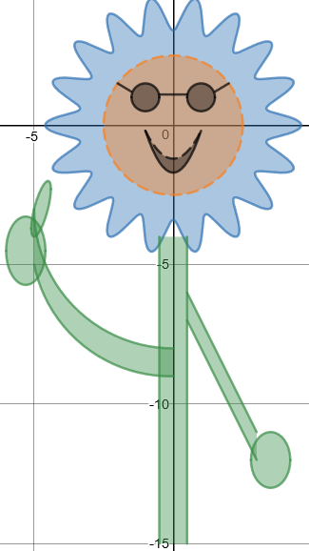

**加油！**